PUBLIC SERVICE ACTIVITY REPORT

U.S. Department of Housing and Urban Development

Consolidated Annual Performance and Evaluation Report (CAPER)

NASSAU URBAN COUNTY CONSORTIUM

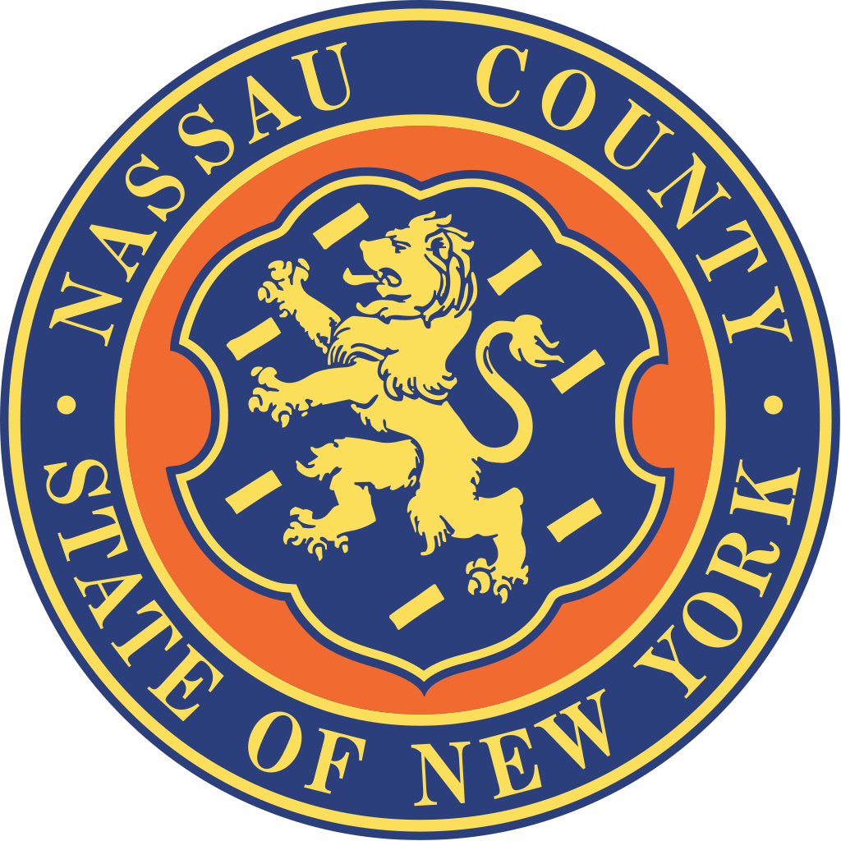

Program Year 2022/48th Program Year

Name of Municipality/Organization

____________________________________________

GENERAL INFORMATION

Municipality/organization:

Address:

Contact Person:

Telephone Number:

Email Address:

CAPER Reporting Forms Officially Submitted by:

Print Name and Title of Authorized Representative

Signature

_________________________________________________________
Date
PUBLIC SERVICE CAPER

ACTIVITY SUMMARY INFORMATION

ACTIVITY NAME: ___________________________________________

ACTIVITY CODE: ___________________________________________

ALLOCATED FUNDS EXPENDED: _____________________________

BENEFICIARY TYPE (Check only one)

Low/Mod Direct Benefit/Limited Clientele (at least 51% of program participants must be low/mod)
Low/Mod Area Benefit (Service Area must be considered low/mod)

Is activity complete? (Yes/No) Are funds remaining? (Yes/No)

ACCOMPLISHMENTS NARRATIVE FOR THIS ACTIVITY

Narrative: Accomplishments narrative MUST be specific and detailed. Please include how budget was allocated (i.e., rent, supplies, stipends) Attach additional documentation if necessary.

Did the activity (check all that apply):

____ Support and promote integrated communities and improve integrated living
patterns? (i.e., public service activities, multifamily rehabilitation, acquisition of property for public purpose, and homeownership assistance)

____ Reduce racially and ethnically concentrated areas of poverty? (i.e. economic
development, public service activities, and homeownership assistance)

____ Respond to identified disproportionate housing needs of persons protected under the Fair Housing Act? (i.e. residential rehabilitaton – for handicapped accessibility improvements, code enforcement, and public housing rehabilitation)

____ Foster and maintain compliance with civil rights and fair housing laws? (i.e., housing counseling, and landlord/tenant counseling)

____ Address disparities in access to key community assets which may provide greater mobility and access to vital assets including economic opportunities, employment, health, transportation and quality education? (i.e. downtown revitalization, public facility and infrastructure improvements, handicapped accessibility improvements, commercial rehabilitation, public service activities, and transportation activities)

Did this activity address any of the nine (9) Impediments to Fair Housing as identified in the Nassau County Analysis of Impediments to Fair Housing Choice (“AI”) located at:

https://www.nassaucountyny.gov/5013/Analysis-of-Impediments-Final-Version--M

(check all that apply):

Impediment #1: Discrimination in the Nassau County Housing Market _____
Impediment #2: Lending Policies, Practices and Disparities _____
Impediment #3: High Cost of Housing _____
Impediment #4: Community Planning & Zoning Decisions That Impede Affordable Housing _____
Impediment #5: Limited Availability of Funds _____
Impediment #6: Limited Non-Profit Capacity _____
Impediment #7: Abandoned / Deteriorated Housing _____
Impediment #8: Employment/Housing/Transportation Linkage _____
Impediment #9: Insufficient Understanding of “Reasonable Accommodations” and ADA _____

LIST IN TABLE BELOW ALL SOURCES OF FUNDING FOR PUBLIC SERVICE ACTIVITY

Federal Funding Sources | Grant or Loan | Amount (000s) | One time award?
(List Agency & Program Names) | Grant or Loan | Amount (000s) | Yes/No
1)
2)
3)
State Funding Sources | Grant or Loan | Amount (000s) | One time award?
(List Agency & Program Names) | Grant or Loan | Amount (000s) | Yes/No
1)
2)
3)
Local (County/Town/Village) Funding Sources | Grant or Loan | Amount (000s) | One time award?
(List Agency & Program Names) | Grant or Loan | Amount (000s) | Yes/No
1)
2)
3)
Private Funding Sources | Grant or Loan | Amount (000s) | One time award?
(Include fund raising, foundation grants, annual pledges, etc.) | Grant or Loan | Amount (000s) | Yes/No
1)
2)
3)

Check ONE accomplishments type:

People (General) _____ Youth _____ Elderly _____ Households _____ Business _____ Housing Units _____

Public Facilities _____ Jobs _____ Loans _____

Beneficiary Totals By Income Group:

Income Category Number

Total Non-Low/Mod Income: _______
Total Moderate Income (<50% AMI > 80% AMI): _______
Total Low Income (< 50% AMI): _______
Total Extremely Low Income (<30% AMI): _______

Beneficiary Total By Racial/Ethnic Group: Information regarding racial/ethnic breakdown on beneficiaries. Because HUD defines “Hispanic” as an ethnic group and not a race, you must classify which racial group you are reporting on is also Hispanic. For example, someone could be classified as White, but also be Hispanic. In this case you would place a number one (1) next to White and a number one (1) next to Hispanic.)

Classification Categories Number Number that are also Hispanic

White _______ _______
Black/African American _______ _______
Asian _______ _______
American Indian/Alaska Native _______ _______
Native Hawaii/Other Pacific Islander _______ _______
American Indian/Alaska Native & White _______ _______
Asian & White _______ _______
Black/African American & White _______ _______
American Indian/Alaska Native & Black _______ _______
Other Multi-Racial _______ _______

Total Number of Persons Assisted _______

DATA COLLECTION SOURCE/ELIGIBILITY INFORMATION

- Please explain HOW income eligibility information was collected (i.e. Referral Agency – NC DSS, Household Income etc.) Be specific about what records are kept to determine eligibility of clientele:

- Of the total benefiting, enter the number that:

Now has new or continuing access to this service or benefit: ________
Now has improved access to this service or benefit: ________
Now receive a service or benefit that is no longer substandard: ________

- If the activity’s National Objective is Low/Mod Area Benefit, please describe the service area and attach a map:

